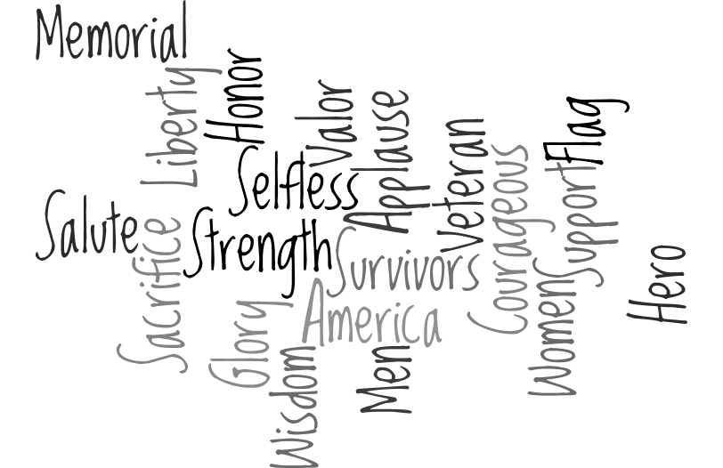

Honoring our Veterans Special Event

At

Sew Colorful Quilt & Fiber Arts Show

Sponsored by Darting Needles Quilt Guild

October 29 & 30, 2016

If you have signed up to donate a completed quilt to our guild show special event

“Honoring our Veterans”

The following information is to provide guidance for the making of the quilt

The quilt should measure at least 60” wide by 80” long.

Please use 100% high quality cotton fabric appropriate for adults.

Please include a label on the quilt with the names of the people who stitched on the quilt. Please make sure there is a space to add the name of the recipient of the quilt.

If you would like to include a note to the recipient please include that with your quilt when you turn it in.

If you have any other questions, please contact Debra McIntire at 920-470-5594